Project Development Phase
Performance Test

Date | 08 October 2026
Team ID | 9100Byte
Project Name | Implement Client Script & UI Policy (Incident)
Maximum Marks | As per evaluation

Model Performance Testing:
Project team shall fill the following information in model performance testing template.
S.No. | Parameter | Screenshot / Values
1. | Incident Form Data Handling | 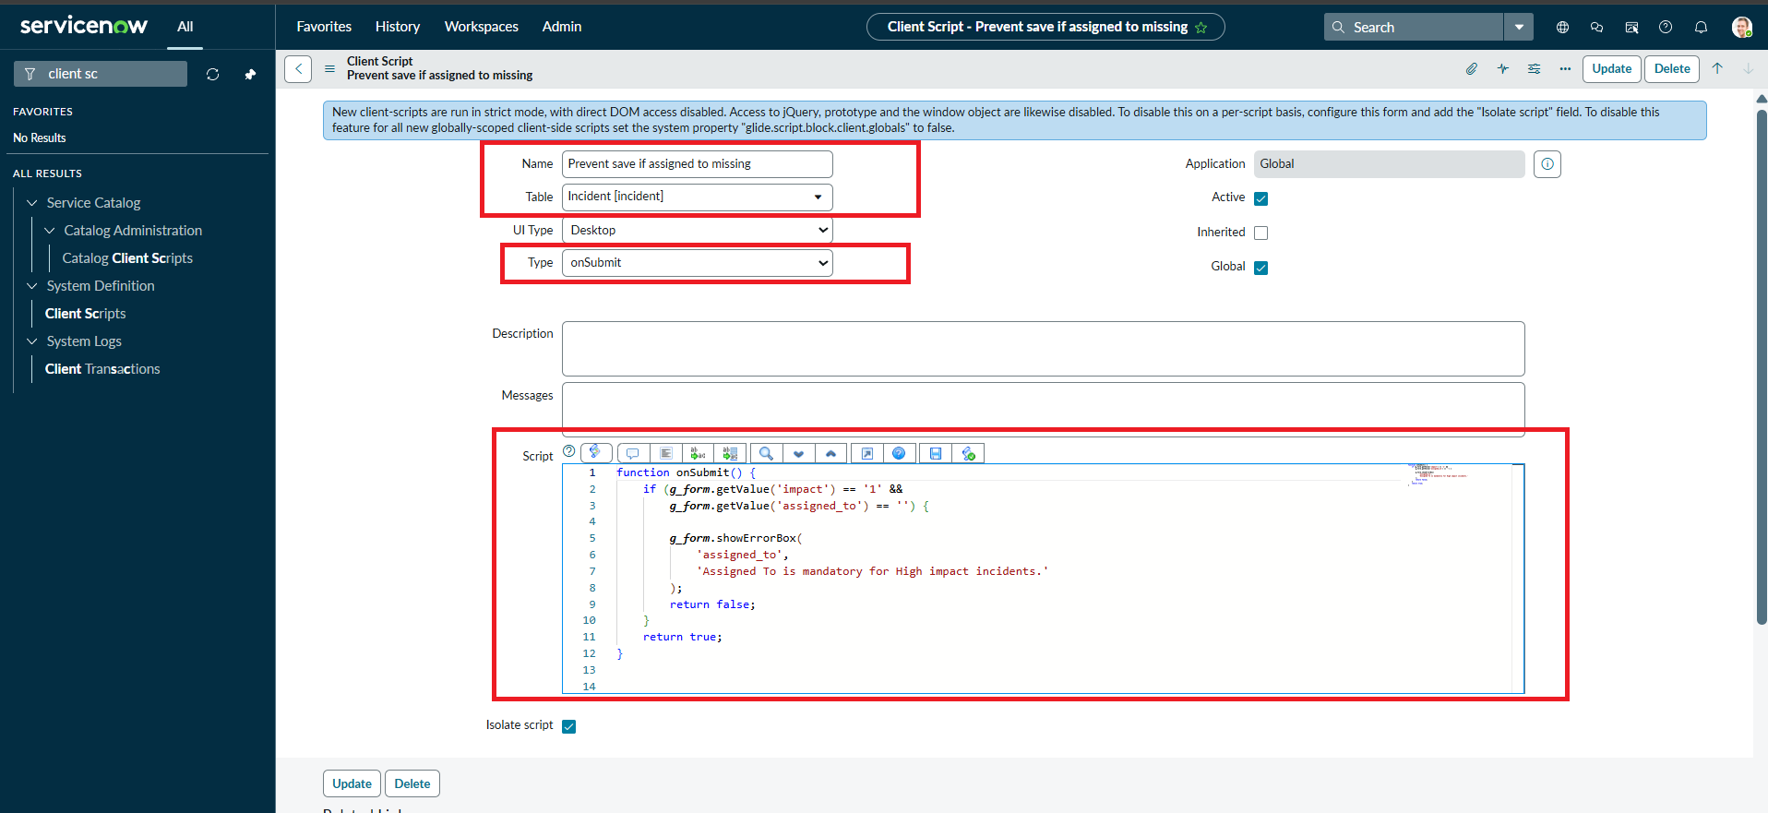
2. | Client-side Validation | 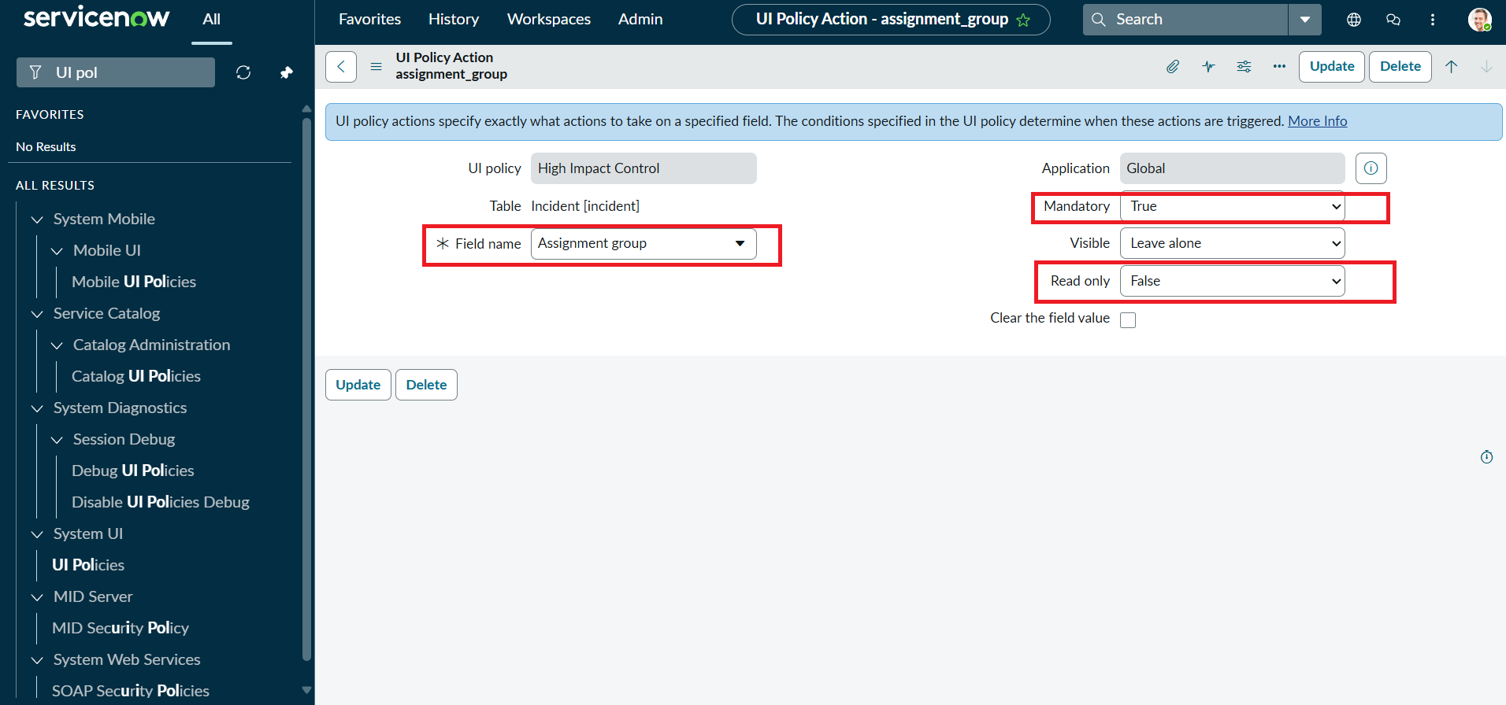
3. | Utilization of Conditional Controls | 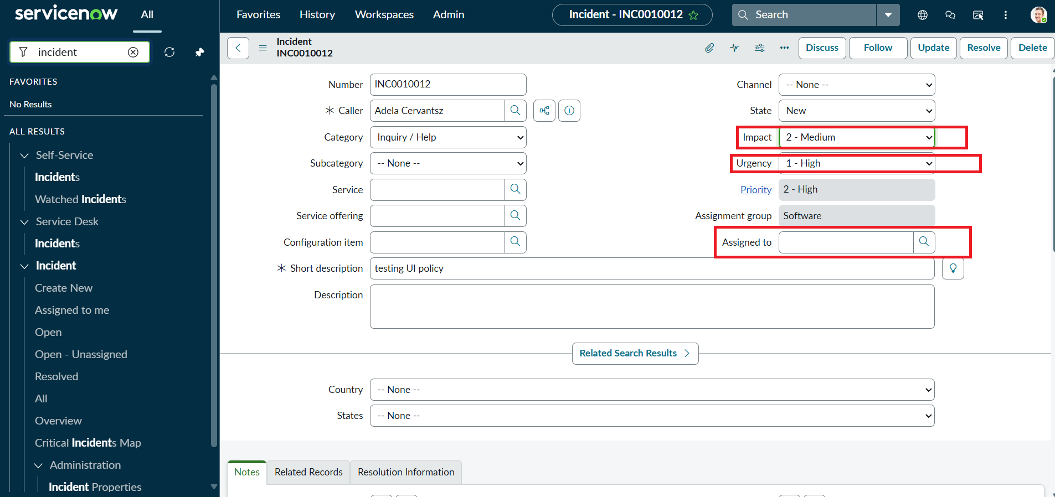
4. | Client Scripts Used | 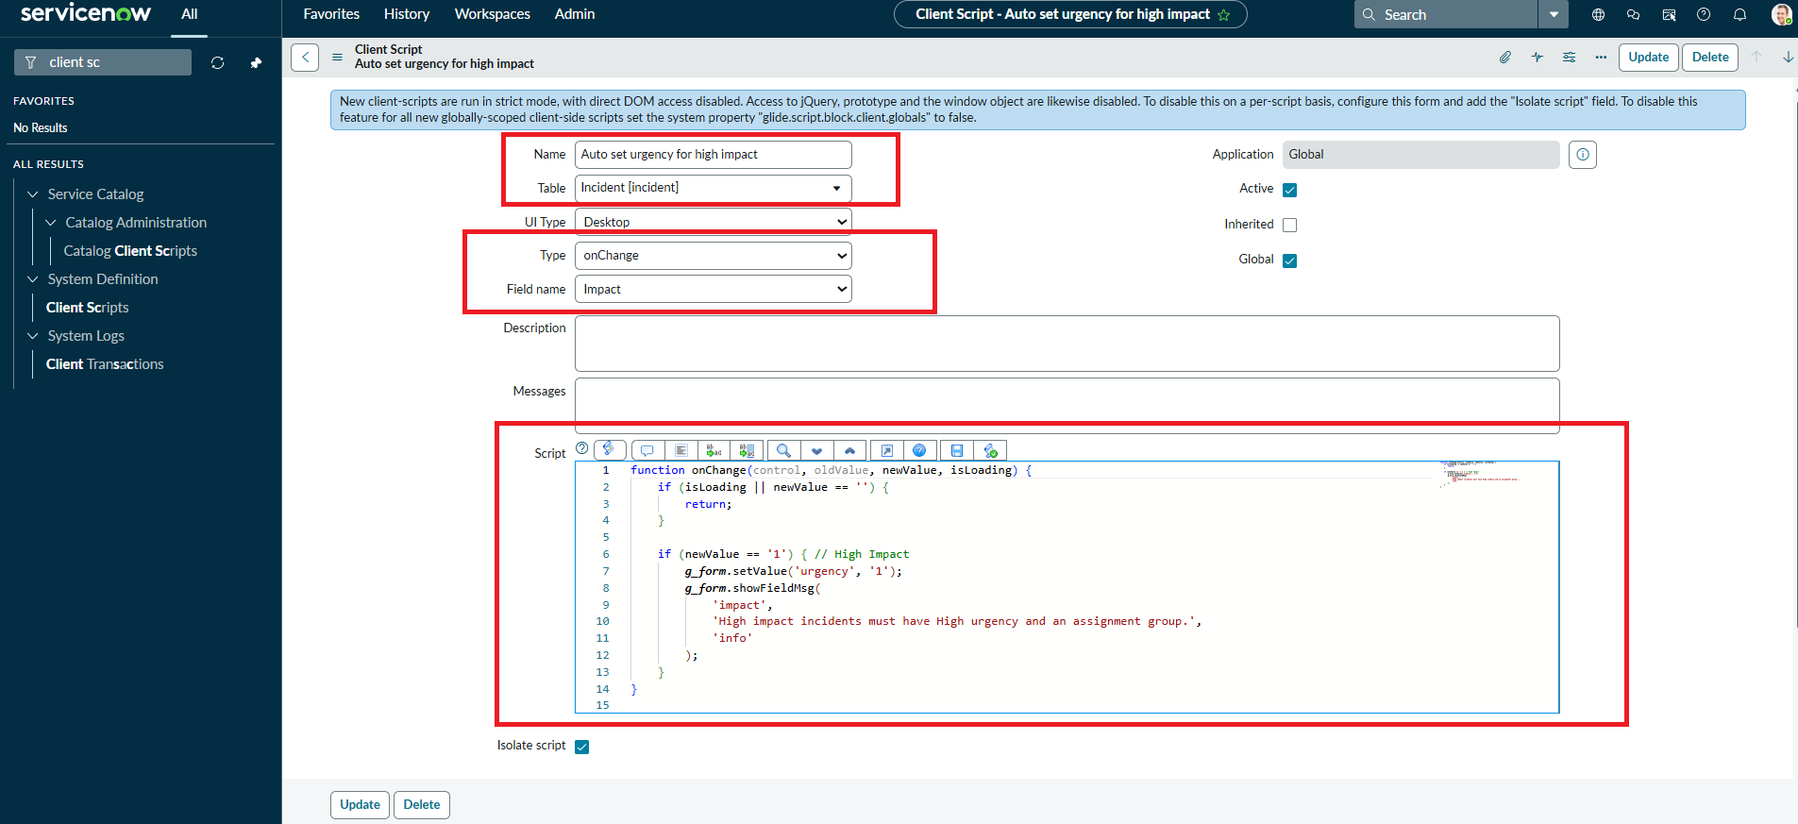
5. | Form Design | 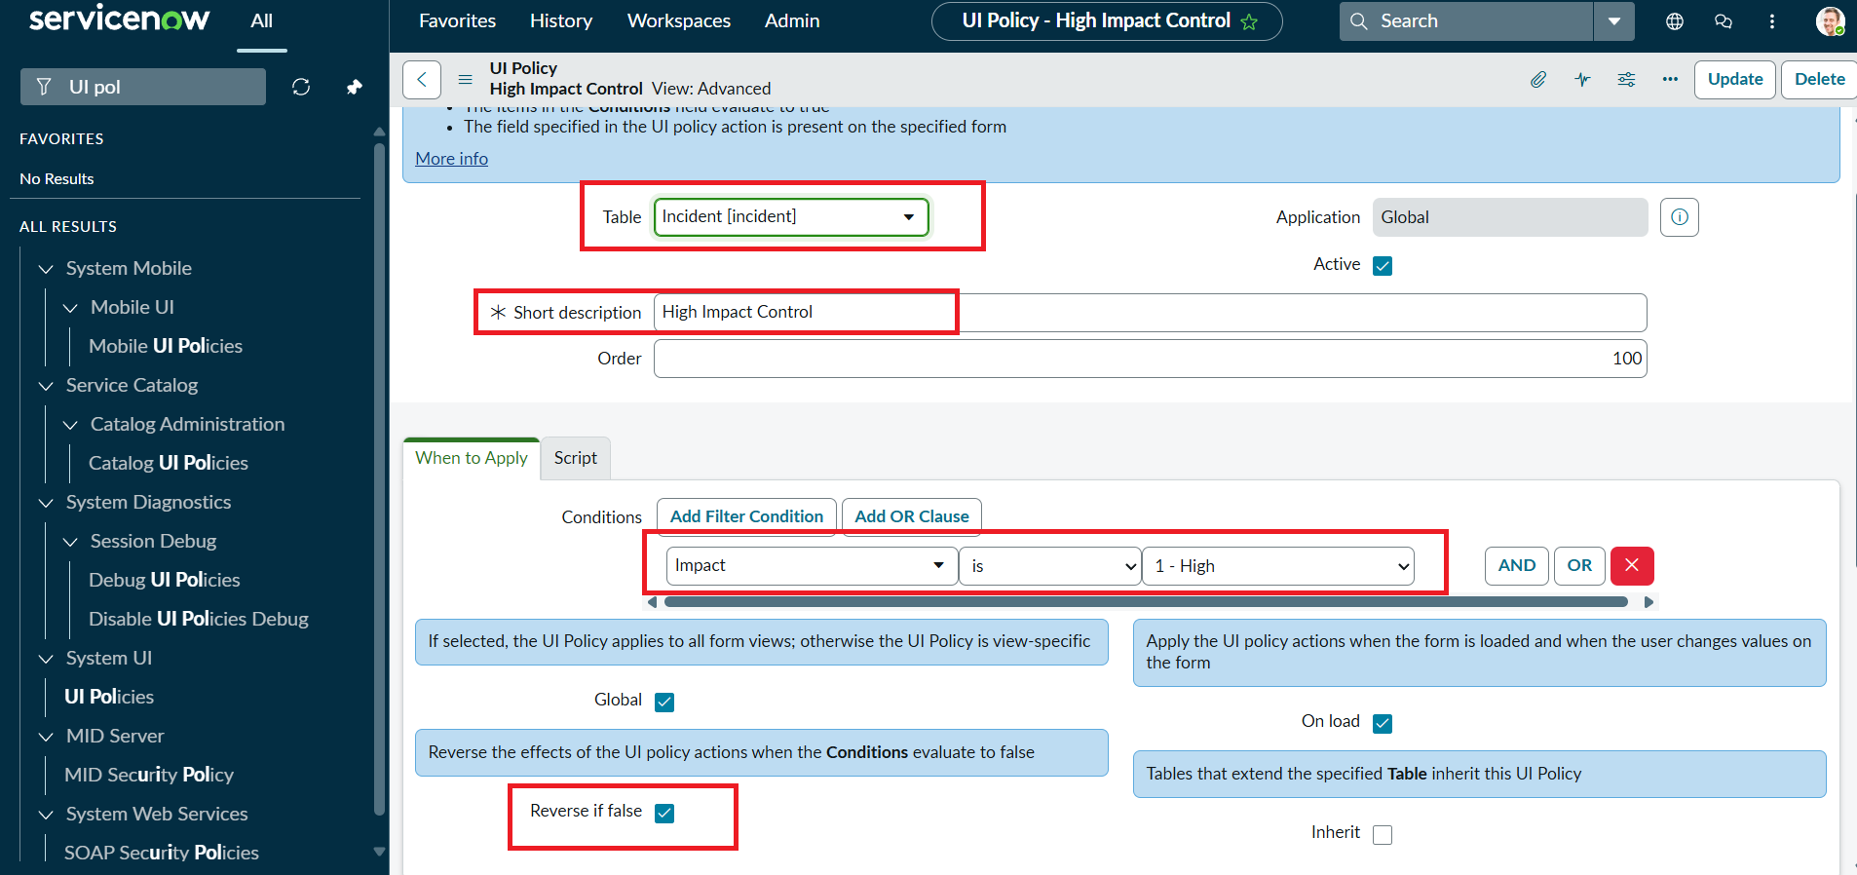
6. | List View Control | 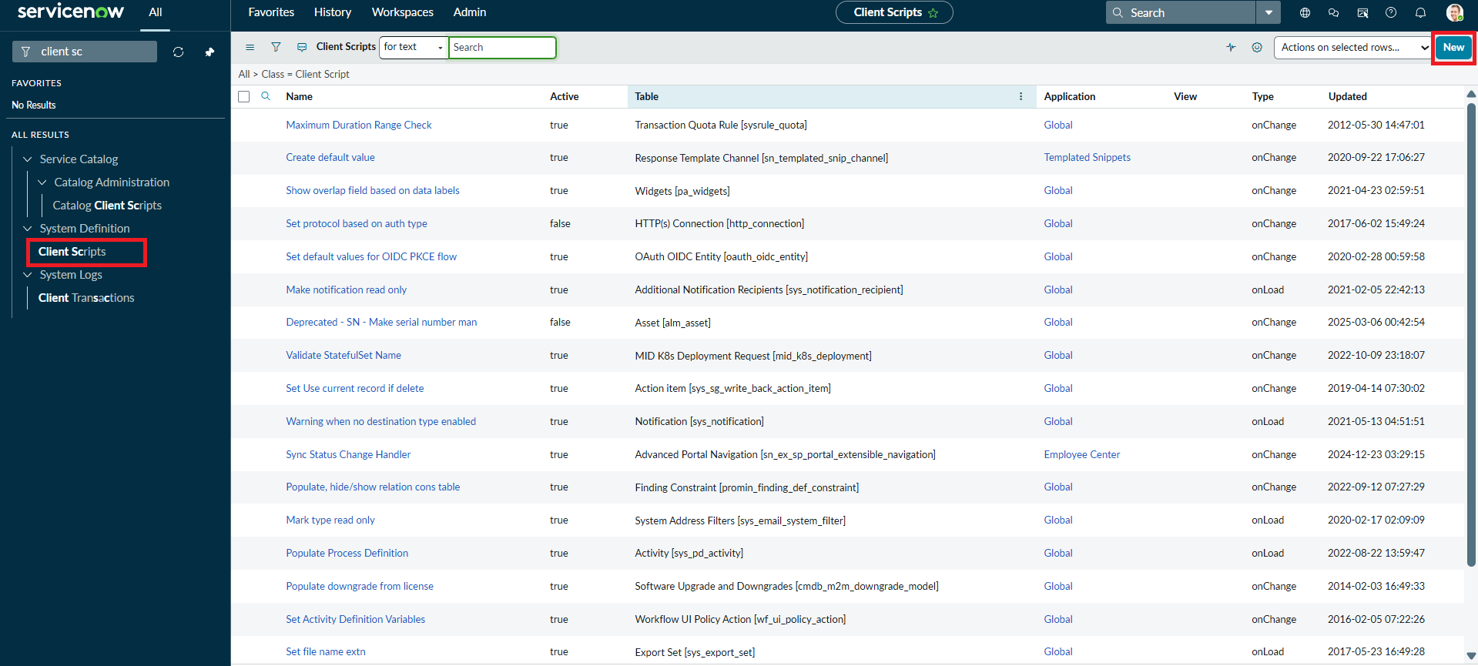

Execution Result Summary
Overall Result: PASS – implementation behavior is evidenced by the supplied ServiceNow screenshots and project document.
UAT Result: PASS – all listed functional scenarios are documented as successfully configured/verified.
Defects: None identified in the supplied evidence.
Evidence Status: Existing screenshots from the submitted implementation document have been retained and reused.
Project: Implement Client Script & UI Policy (Incident) | Team: 9100Byte | Date: 08 October 2026
ServiceNow Implementation Evidence
Evidence: Supplied ServiceNow implementation screenshot(s).
image7.png
image3.png
image12.png
image6.png

